12U+ Practice Season Long Practice Plan
V2.2 - Feb 2026

Practice #1
Time | Content
*Equipment needed: 1 bownet, 4 buckets
5:30 - 5:35 | Meet Your Team  - Intros - Name + Favorite position + Favorite movie  - Coach expectations: effort and attitude
5:35 - 5:45 | Warmups - Standing on the 3B line in the OF facing center field  - Knee Hugs - walk to 2B line + backpedal back  - Monster Walks - kick one leg out and try to touch toe - walk to 2B line + backpedal back  - Lunge Twists - to 2B line & backpedal back (lunge and twist to front leg side; stand up, lunge with other leg)  - Spidermans - 5 to each side. (Start in a squatted position, with the hands touching the ground. Slowly crawl out with your hands and bring your leg out in the lunge position, outside of the hands, reach arm to the sky. Repeat)  - Figure 4s - Pull your leg into your chest by grabbing your shine bone. Make sure the leg is pulled higher than the hip. Try and pull the leg so that your lower leg is parallel with the ground.  - Quad Pulls + Dancers (5 each side) - Grab foot behind you, bend at hip with other arm out in front of you  - Arm Circles  - Arm bar stretches across torso  - Shoulder internal & external rotations (U shapes)
5:45-6 | Introduce High-Level Throwing Pattern  - HLT Pattern Overview  - How To Throw A Softball  - Girls circle around coach. Breakdown:  - "Ready" - Player facing forward with ball in her glove  - "Right, Left, Sideways" - Player steps in front with right foot (righties) at 45 degree, Player gets other foot forward to land sideways to their target in athletic position  - "Transfer" - Player get ball into their throwing hand  - "Scap Pull” or “Shoulder Pull” -> Player pulls shoulder blades back and gets glove out in front  - "Ball Near Ear" -> Player makes sure the ball stays near their ear. We do not want the ball facing away behind them nor have a "big" angle between their upper and lower arm  - "Knee" -> Just like in hitting, we want the rear hip to rotate with the knee moving in to start the throw with lower body movement  - "Torso" -> Twist torso & shoulders forward before moving the ball forward  - "Throw & Follow-Through" -> Ball moves up and out, is released, and player follows through across their body  Summary Coaching Point if nothing else  - Good athletic position  - Focus on scapula pull - pinching shoulder blades!!!!  - Throwing power comes from lower body  DRILL - Players get in two lines and just throw
6 | Introduce our role model for the season, Sierra Romero is one of the best IFs to ever play college softball. SierraRomero (print this before practice)  - Ask kids what they see  Coaching points:  - Must first be mentally prepared for the ball to be batted in her direction, prior to the pitch being delivered. Locked in on the ball. Where am I going if the ball comes to me?  - Knees and back should be bent comfortably.  - Feet should be placed slightly wider than shoulder width apart. On the balls of feet.  - Arms should be placed comfortably out in front of her body, but not too far.  - At the moment the ball crosses home plate, your palms should be relaxed and directed inward and slightly upward, about body width apart.  - Hands should be extended naturally.  - Your weight should be distributed evenly on the balls of her feet.  Follow up by sending an email asking them to watch this video: Get to Know Michigan All-American Sierra Romero
6:05  -  6:10 | Demonstrate Fielding A Ground Ball Softball Infield Drills - Technique on How to Field a Groundball  Points to coach:  - Triangle between feet and glove  - Approach a ground ball as if you were an airplane coming in for a landing, vs a helicopter suddenly lowering itself  - Glove is a wall not a ramp  - Keep head down and watch ball all the way into glove  - “Right, left field”
6:10  -  6:25 | Snake Drill Infield Training and Drills for All Levels  4 buckets, coach on knee next to bucket. Girls field and place ball in bucket. Coaches are triangles, circles are buckets, circles w/X are starting pts for girls.  Coach rolls the ball. Player fields it and either puts it into the bucket or throws back to coach. Then they run around bucket and field a ball rolled to them from the coach at the next buck.  Progression:  - Charge the ball, field it, and put it into the bucket  - Remind them, right, left, field, and put it into the bucket  - Field the ball, jab step, and throw to coach  Coaching points:  - 1B extension. Know when to come off the base  - Straddle 2B and 3B  - Block tag  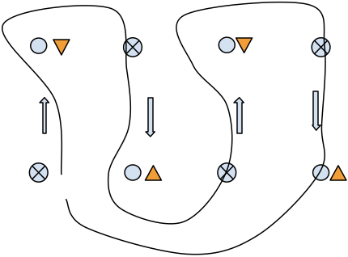
6:25  -  6:30 | Hitting Demonstration and Bat Safety  - Safety  - Set ground rules for when girls should swing bats (e.g. away from other players, only when instructed to do so by a coach)  - make sure they always swing bats with a helmet on  - Hitting Demonstration. How To Hit A Softball.  - Hands  - If player is righty, right hand on top of bat  - Line up door knocking knuckles  - Feet:  - Feet outside hips, knees inside feet, slight knee bend, and slight bend at waist  - Toes, hips and shoulders should be facing plate  - Load  - Like in golf or tennis, to swing forward, you must first by going backwards with your swing  - As pitcher begins motion, begin to transfer weight back. Probably about 60% of weight is on back and 40% is on front  - Weight comes off front foot (i.e. slight heel lift) and is now more focused on inside of back leg  - Hip rotation initiated by back knee driving forward violently  - Weight moving forward at contact  - At point of contact top hand should be facing up, bottom hand facing down  - Follow through
6:30  -  7:00 | Station A - PVC Station  - Hitting Drill To Engage The Hips  - 3 SIMPLE Hitting Drills With PVC To Improve Body Control - Hip Activation - Baseball Hitting Tips  Station B - Tee. Have the player swing in slow motion to the point-of-contact and stop. Check that they fired their hips and are palm up, palm down. Then reset and hit the ball. https://www.instagram.com/p/CP8iaOdA9wA/  Station C - Live pitching from P1 and coach or Batting cage (if available)

Practice #2
Time | Content
*Equipment: Sliding mat, cones
*Setup: Sliding mat setup in LF
5:30-5:40 | Warmups  - Knee Hugs - walk to 2B line + backpedal back  - Monster Walks - kick one leg out and try to touch toe - walk to 2B line + backpedal back  - Lunge Twists - to 2B line & backpedal back (lunge and twist to front leg side; stand up, lunge with other leg)  - Spidermans - 5 to each side. (Start in a squatted position, with the hands touching the ground. Slowly crawl out with your hands and bring your leg out in the lunge position, outside of the hands, reach arm to the sky. Repeat)  - Figure 4s - Pull your leg into your chest by grabbing your shine bone. Make sure the leg is pulled higher than the hip. Try and pull the leg so that your lower leg is parallel with the ground.  - Quad Pulls + Dancers (5 each side) - Grab foot behind you, bend at hip with other arm out in front of you  - Arm Circles  - Arm bar stretches across torso  - Shoulder internal & external rotations (U shapes)
5:40-5:50 | Throwing progression - Two lines - 8’ apart (or one line at fence) - Pick 1-2  - Warmups & Activations  - Simple Scap Pull (no throws)  - Kneeling Throw (into fence as team)  - Staggered Stance (into fence or to each other)  - Shuffle Throw (into fence or to each other)  - Hop Back | Backpedal Turn & Throw  - Pivot Throws  - Rocking Throw  - Kneeling Away Turn & Throw
5:50  -  6:35 | Divide into 3 groups. Catchers + 2 other groups  Catchers do stations: A, C, D  Everyone else does stations:: A, B, C  15 minutes each station  Station A: Sliding (Setup sliding mat in LF)  How To Slide In Softball and Baseball - skip pop up  Progression:  - Sitting in figure four  - On edge of sliding mat  - One step back from sliding mat  - Full run to sliding mat  Coaching points:  - Figure-4  - Hands up  - Toes up. Don’t catch a cleat in the dirt and break an ankle  Station B: Outfield Drills in RF  - Drill #1. Fly route - Two lines with two coaches. Place a cone 12 feet in front of each line.  - The player start running to the cone and makes a hard turn. The left line, breaks left, right line breaks right. Coach make a throw that the player catches on the run.  - Same, but a fade route. This video, https://youtu.be/8w6U8-c1wqY?t=52, from 0:52 to 0:55 show the fade route  - Drill #2. Jump over cones and then drop step  - https://www.youtube.com/watch?v=O5_YeW6d1OA  - Drill #3. Two girls standing in OF side by side (simulate RC & RF) - Throw near/between them, have them call mine, one catch w/ other back up  Station C - Baserunning (at 1B)  - Rocker Start - How to Take a Baserunning Lead  - Note this is different than baseball  - Can’t leave the base until the ball leaves the pitchers hand  - The rocker start allows the runner to get momentum going before their foot leaves the base  - Have each player take their lead and then return to 1B  - Stealing  - Tell them the sign you will use for the season  - “If you get the steal sign from coach, you go. It’s on us as long as you run hard and don’t hesitate.”  - Have each player receive a sign from 3B coach and steal to 2B.  - At 2B  - Repeat taking a lead and returning to 2B  - Steal 3B  Station D: Catchers  - Position 1 & 2. Catcher Stances  - Throw down to 2B and 3B
6:35 | - Water break
6:40 | Games!  - Total Bases Game  - 3 teams of 4 (2 hitting team + fielding team of 2 IF + 2 OF  - Hit off tee -> Count total bases advanced until ball reaches an IF securely.  - Spin & Hit - Spin around 2x with head on bat, then try to hit off tee

Practice #3
Time | Content
*Setup: Cones & bucket in OF for the OF drill below; no bownets; CHALK lines
5:30-5:40 | Warmups  - Knee Hugs  - Monster Walks  - Lunge Twists  - Spidermans  - Figure 4s  - Quad Pulls + Dancers  - Arm Circles  - Arm bar stretches across torso  - Shoulder internal & external rotations (U shapes)
5:40-5:50 | Throwing progression - Two lines - 8’ apart (or one line at fence) - Pick 1-2  - Warmups & Activations  - Simple Scap Pull (no throws)  - Kneeling Throw (into fence as team)  - Staggered Stance (into fence or to each other)  - Shuffle Throw (into fence or to each other)  - Hop Back | Backpedal Turn & Throw  - Pivot Throws  - Rocking Throw  - Kneeling Away Turn & Throw
5:50  -  6:30 | Two groups. 20 minutes at each station, with two drills per station  Station A  A1: Introduce Stealing Home - Baserunning. [10 min]  - Take lead when ball crosses home plate / leaves pitchers hand  - Run in foul territory. If you are hit by the ball in fair territory you’re out.  - Steal if catcher drops the ball or pitcher fumbles the ball  - If in pickle, stay in it as long as possible. Don’t give up. The fielding team may make a mistake. This gives an opportunity for other runners to advance.  - If coach says to steal, go no matter what  DRILL: Line up at 3rd. Coach either pitches to catcher or a pass ball. Runner steals home or returns to base.  A2: Introduce Stealing Home - Fielding. [10 min]  - If ball goes to backstop, pitcher crashes in to cover home and catcher under hands ball to pitcher to make the play on the runner stealing home.  - Pitcher crashes on pass ball. Points to where the ball is. Don’t block home plate. Left foot at corner.  - First is backup for throw to pitcher  - 3rd base follows runner half way  - Short stop covers 3rd  DRILL: [C, P, 1, 3, SS, runners on 1st and 3rd]  Ask runner on 3rd to be aggressive and force fielders to make a play  Questions  - What happens if C throws to 2? Runner on 3B scores  - What happens if the C’s throw goes over the P’s head? Runner on 3B scores. Be careful with the ball. Control the base paths.  Station B in OF  B1: “Tough” Fly balls [10 min]  - Fly ball machine (moving it around) - “Tough” fly balls over each shoulder, short ones they need to run in  - Focus: Getting good jump on that ball + drop steps + quick recoveries w/ GOOD throws into coach  B2: Hitting - 3 sub-stations w/ 2 bownets [10 min]  - Heavies or Wiffles - pitched by coach  - Soft toss  - Tee - Self-service station by players
6:30  -  7:00 | Situations.  Three teams: batting, infield, outfield  Rotate after 10 minutes  Coach pitch  - Ball to 2nd  - Who covers 2nd?  - Ball, base, backup  - Ball to SS  - Who covers 2nd? if 2nd forgets center field covers 2nd.  - Ball to 1st  - Who covers 1st?  - Focus: Stealing home  - Runners on 1B and 3B. Catcher can’t throw when 1B runner steals  - Pass ball  - Ball to pitcher  - Jog to first and under hand  - Ball to Center field. Relay in  Coaching points:  - Ask them all to point where they are going with ball if it comes to them  - You will need to remind the players to take their lead every pitch  - They must steal if given the sign  - Runners cannot steal home, so the catcher’s throw to 2B on a steal is free

Practice #4
Time | Content
*Setup: 2xBownet, home plate, and cones in right field;
5:30-5:40 | Warmups  - Knee Hugs  - Monster Walks  - Lunge Twists  - Spidermans  - Figure 4s  - Quad Pulls + Dancers  - Arm Circles  - Arm bar stretches across torso  - Shoulder internal & external rotations (U shapes)
5:40-5:50 | Throwing progression - Two lines - 8’ apart (or one line at fence) - Pick 1-2  - Warmups & Activations  - Simple Scap Pull (no throws)  - Kneeling Throw (into fence as team)  - Staggered Stance (into fence or to each other)  - Shuffle Throw (into fence or to each other)  - Hop Back | Backpedal Turn & Throw  - Pivot Throws  - Rocking Throw  - Kneeling Away Turn & Throw
5:50  -  5:55 | Review Stealing Home  - Batter  - Back straight back to backstop a couple steps  - Leaving room for runner to slide  - Runner has to judge where ball is and if opportunity  - Runner should take lead down the line each time  - Runs hard, slides always. Kick up enough dust so the umpire can’t see clearly.  - Force catcher to work. If the pitcher turns their back on the runner: GO!  - Pitcher  - Points / Yells ball location, while running to cover home  - Setups up in front of plate; don’t get run over  - Don’t get spiked  - Catcher  - Locate ball  - Decide underhand or dart overhand throw  - Don’t wait for pitcher to be there, lead the pitcher  Drill: Coach pitcher and coach catcher. Players lined up at 3B. Coach pitches ball to C (sometimes strike, sometimes passed ball) - Baserunners go or return to 3B.
5:55  -  6:35 | Station A (at home plate)  10 minutes each  Station A1 - Introduce Batting Signs  - Introduce your batting signs  - Hit away  - Bunt  - Fake bunt  - Show them how to step out of the batters box and receive a sign from the 3B coach  - Give each kid three pitches; have them pretend to swing a bat and then step out for the sign after each pitch.  Station A2 - Dropped 3rd Strike - Dropped Strike  - Education:  - Dropped 3rd strike applies:  - if 1st base is unoccupied during pitch with < 2 outs  - Or 2 outs  - Batter-runner goes on any 3rd strike the catcher drops. Bounces from the pitcher are “dropped” even if caught.  - Drill  - Batter with helmet but no bat, 1st baseman, catcher, runners  - Coach pitches ball either to catcher or into dirt; batter pretends to swing and runs  - Depending on ball, catcher has to make throw to first  - If in foul, first base should place foot on orange bag  - If in fair, first base place foot on white bag as normal  Station B (in OF)  Station B1 - Relay drill  7 minutes each  - Cut 2 from RF. Girls are divided between SS, 2nd, RC.  - Coach hits/throws ball into outfield.  - 2nd is cut. Arms up, “ball, ball, ball”  - SS covers 2nd and yells instructions “left”, “right”, “stop” to create straight line between 2nd base, 2B player, and outfield player with the ball. Throw to 2B through relay. Then introduce a runner at home that goes on the throw.  - Cut 2 from LF. Girls are divided between SS, 2, LC.  - Coach throws ball into outfield.  - SS is cut. Arms up, “ball, ball, ball”  - 2 covers 2nd and yells instructions “left”, “right”, “stop” to create straight line between 2nd base, 2nd basemen, and outfield player with the ball. Throw to second through relay. Then introduce a runner at home that goes on the throw.  - Cut 3 from LF. Girls are divided between SS, 2, LC.  - Coach throws ball into outfield.  - SS is cut. Arms up, “ball, ball, ball”  - 2 covers 2nd and yells instructions “left”, “right”, “stop” to create straight line between 3rd base, SS, and outfield player with the ball. Throw to third through relay. Then introduce a runner at home that goes on the throw.
6:35 | Water break - Catcher get into gear
6:40  -  7:00 | 3 teams: batting, IF, OF  Rotate every 7 minutes  Situations  - Focus: Stealing home  - Runners on 1B and 3B. Catcher can’t throw when 1B runner steals  - Pass ball  - Need to be smart with the ball. Only throw ball ahead of the runner. If you're too late, throw to the pitcher to kill the play. Every throw could be dropped; if it is bumbled or dropped, what is the runner going to do?  - If they are handling stealing home scenarios well:  - Fielding and baserunning for pop-flys  - Bunt coverage

Practice #5
Time | Content
*Equipment: 2xPVC, Tee
*Setup: 2xBownet, home plate, and cones in right field;
5:30  -  5:40 | Warmups  - Knee Hugs  - Monster Walks  - Lunge Twists  - Spidermans  - Figure 4s  - Quad Pulls + Dancers  - Arm Circles  - Arm bar stretches across torso  - Shoulder internal & external rotations (U shapes)
5:40  -  6:00 | Continuation  - Offensively - If runner on 3B and you are walked, we do Continuation. If C throws to 2B, 3B runner goes home. If C throws to SS, go back to 3B FAST.  - Defensively - C do not throw to 2B, instead throw to SS then right back home  - DRILL  - 4 fielders (1B/2B/3B/C; coach P) + everyone else are runners at home  - Batter-runner runs as if walked  - First base coach gives continuation sign  - Runner must not slow down  - After play runner advances to 3B  - Have the catcher throw down to 2B. Learn they do not want to do this as the 3B runner scores. Best to kill the play back to the pitcher.
6:00  -  6:20 | Batting Stations  - PVC  - Hitting Drill To Engage The Hips  - 3 SIMPLE Hitting Drills With PVC To Improve Body Control - Hip Activation - Baseball Hitting Tips  - Tee. Eye tracking. Image the ball is being throw by the pitcher (look past bow net), eyes track to tee as bat is swung, keep eyes on tee for 3 seconds (kids count 1,2,3)  - Live pitching in the IF.  - Batting cage (if available)
 | At 6:15 pitchers start warming up and catchers get gear on
6:20  -  7:00 | Scrimmage (2 innings)  The purpose here is to have the players hit against live pitching and see game flow before your first game. Coaches play outfield.

Practice #6
Time | Content
*Setup: 2xBownet, home plate, and cones in right field;
5:30-5:40 | Warmups  - Knee Hugs  - Monster Walks  - Lunge Twists  - Spidermans  - Figure 4s  - Quad Pulls + Dancers  - Arm Circles  - Arm bar stretches across torso  - Shoulder internal & external rotations (U shapes)
5:40-5:50 | Throwing progression - Two lines - 8’ apart (or one line at fence) - Pick 1-2  - Warmups & Activations  - Simple Scap Pull (no throws)  - Kneeling Throw (into fence as team)  - Staggered Stance (into fence or to each other)  - Shuffle Throw (into fence or to each other)  - Hop Back | Backpedal Turn & Throw  - Pivot Throws  - Rocking Throw  - Kneeling Away Turn & Throw
5:50  -  5:55 | Backhand / forehand muscle memory  Backhand / forehand video  - Before practice, place 5 cones for each player with ball on top  - Forehand, backhand, closed backhand, drop-step backhand, reset  - Forehand, drop-step forehand, closed forehand, drop-step forehand, reset
5:55  -  6:10 | Backhand / forehand fielding drill. Girls pair up in line facing each other, 8 feet apart. They roll the ball to each other and practice fielding.  Progression:  - Bare hand  - Glove  - Bounce  - Glove side  - Backhand  - With mit, field ball, then drop it and use bare throwing hand to pick. Much faster than picking it up with a glove and then transferring it to throwing hand.
6:10 | Water break - Bats and hats
6:15  -  6:45 | Fielding Footwork Drill - [bownet at 1st]  “Right, left field; right, left throw”  8 minutes per station  Station A at 2nd (between 1B and 2B)  - Ball on top of cone: Softball Infield Drills- Footwork & Body Control  - Want momentum towards 1st base  - Stutter step  - Pause on right foot  - Right, left, pause  - Glove under left eye, Glove under left eye  - No throw  Station B at SS  - Right/left pause, right/left pause from rolled ball: 3 Infield Drills For Youth Players/Beginners  - Two cones with balls on top. Coach rolls third ball.  - Stutter, right, left, pause,  Station C at 3B  - Around cone and then coach rolls ball: 4 Infield Drills for Team Practice. One cone.  - Start in front of cone. Coach says Go  - Quick feet around cone counter-clockwise  - Coach rolls ball  - Right, left, pause. Coach checks form.  - Right, left shuffle and throw  - Balance on right leg  - Coach rolls ball to player’s left leg  - Shuffle and throw  Coaching points:  - Field ball on left side of body  - Keep head down. Watch the ball all the way into mit. If head comes up, mit comes up.
6:45  -  7:00 | Queen of the Hill Game Off Pitching Machine  - 3 pitches, you have to swing. Any contact keeps you in. Miss and you are out. Bad pitch then that’s bad luck. If you are out you go to the field.  - You can get back in by catching a pop-fly or by cleanly fielding a ball and making a throw to 1st base.  - Go to two pitches after first round, one pitch after second round.

Practice #7
Time | Content
*Equipment: PVC, tee
5:30-5:40 | Warmups  - Knee Hugs  - Monster Walks  - Lunge Twists  - Spidermans  - Figure 4s  - Quad Pulls + Dancers  - Arm Circles  - Arm bar stretches across torso  - Shoulder internal & external rotations (U shapes)
5:40-5:50 | Throwing progression - Two lines - 8’ apart (or one line at fence) - Pick 1-2  - Warmups & Activations  - Simple Scap Pull (no throws)  - Kneeling Throw (into fence as team)  - Staggered Stance (into fence or to each other)  - Shuffle Throw (into fence or to each other)  - Hop Back | Backpedal Turn & Throw  - Pivot Throws  - Rocking Throw  - Kneeling Away Turn & Throw
5:50  -  6:00 | Review  - Signs  - Hit away, bunt, fake bunt, take  - Steal, continuation  - Romero  - Focus  - Stance. Shouldn’t be on heels. Need to be on the balls of feet to explode in any direction
6:00 - 6:25 | Catcher Group:  Fielder Group: everyone else  Catchers (will be working at catcher, pitchers circle, 1B) - need ladder or two, cones, and balls  - Warmups -  - Side to sides in crouch  - Crab walks left, walks right, walks back, walks forward  - Position 1 -> down to block. Up. Repeat - Focus on torso bent forward, glove turned over and down to dirt, head down watching ball.  - Dont forget to look for sign every time.  - Drill 1 - Blocking to Side - Players in semi circle around fake plates (and home plate). Toss one ball to either left or right of one player. All catchers move together down to block.  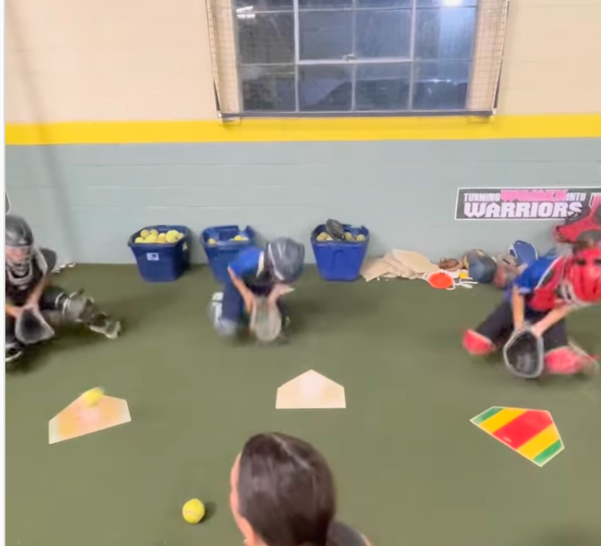  - Drill 2 - Ladder PitchCall-to-P1 (set up two ladders) - In pitch calling, our feet are close (inside the ladder) glove is on the outside of our leg, hand is tight to the color of our pants. In pop, our feet go wider, our glove goes into a low target with a bent arm and loose wrist. As we pop, we stay low and out of the umpire's line of sight.  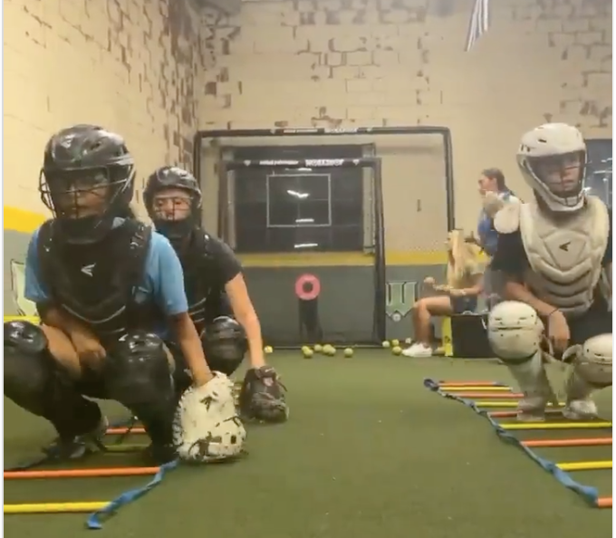  - Drill 3 - Passed Ball Coverage at Home - 4 coned balls behind catcher. Catcher in block position. Coach says a cone, catcher gets and flips to coach at home.  - Drill 4 - Dropped 3rd Strike Drill - Cones ball on dirt in various spots in front of plate. Catcher gets in P1, drops to knees in blocking formation, gets up and races to pick up coned ball and throw to 1B (coach)  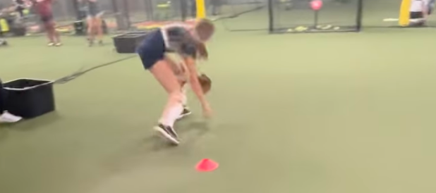  - Drill 5 - Bunt Coverage - Coach bunts down 3B line -> Catcher in P1, races to bunt, throws to 1B  Fielding Drill [bownet at 1st]  Fast Footwork, Strong Fielding, Fast Good Throws. Explain how crucial footwork is to fast fielding: “Right left field, right left throw”. Need to be on your toes and ready to move fast  8 minutes per station  Three drills in parallel at 2nd, SS, 3rd  Station A - Two cones about 10 feet apart. Stutter step from back cone to front cone. Player continues to stutter step. Coach rolls ball, player fields it and gets into throwing position with arms pulled back and elbows up. Softball Infield Drills- Footwork & Body Control  Station B - Hop over line of cones and coach rolls a ball. Softball Infield Drills- Footwork and Direction  Station C - Shuffle between two cones - start at right cone shuffle in ready position to and touch left cone,coach rolls ball when they touch cone to the right of the right cone. Softball Infield Drills- Side to Side Shuffle & Throw
6:25 | Water Break
6:30  -  7:00 | Batting Stations  - PVC  - Top hand / bottom hand  - Live pitching or pitching machine  - Batting cage (if available)

Practice #8
Time | Content
*Setup: Bownet near 1B; Cones & bucket in OF for the OF drill; Sliding pad
5:30-5:40 | Warmups  - Knee Hugs  - Monster Walks  - Lunge Twists  - Spidermans  - Figure 4s  - Quad Pulls + Dancers  - Arm Circles  - Arm bar stretches across torso  - Shoulder internal & external rotations (U shapes)
5:40-5:50 | Throwing progression - Two lines - 8’ apart (or one line at fence) - Pick 1-2  - Warmups & Activations  - Simple Scap Pull (no throws)  - Kneeling Throw (into fence as team)  - Staggered Stance (into fence or to each other)  - Shuffle Throw (into fence or to each other)  - Hop Back | Backpedal Turn & Throw  - Pivot Throws  - Rocking Throw  - Kneeling Away Turn & Throw
5:50  -  6:30 | Station 1a: Backhand Drill (3 stations across IF) [10 minutes]  - Backhand Raking Drill - 5 cones in a straight line from far back SS towards pitcher circle. Player starts behind cone line and never stops moving always facing coach. Move around cones (forward + backpedaling) and flip ball back to coach. Goal: Keep momentum going through the ball, focusing on raking through your backhand. -> Three balls each and swap  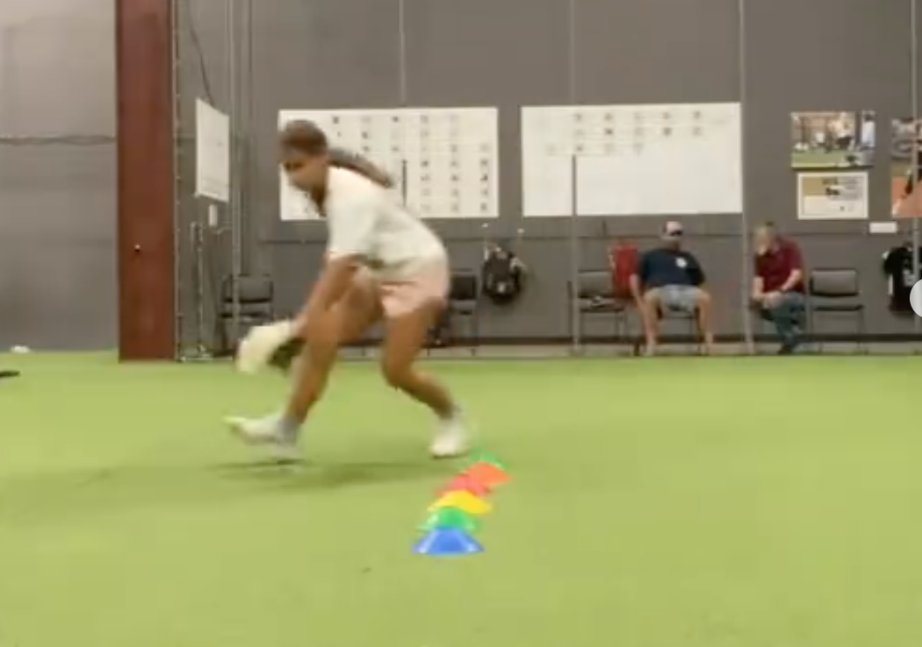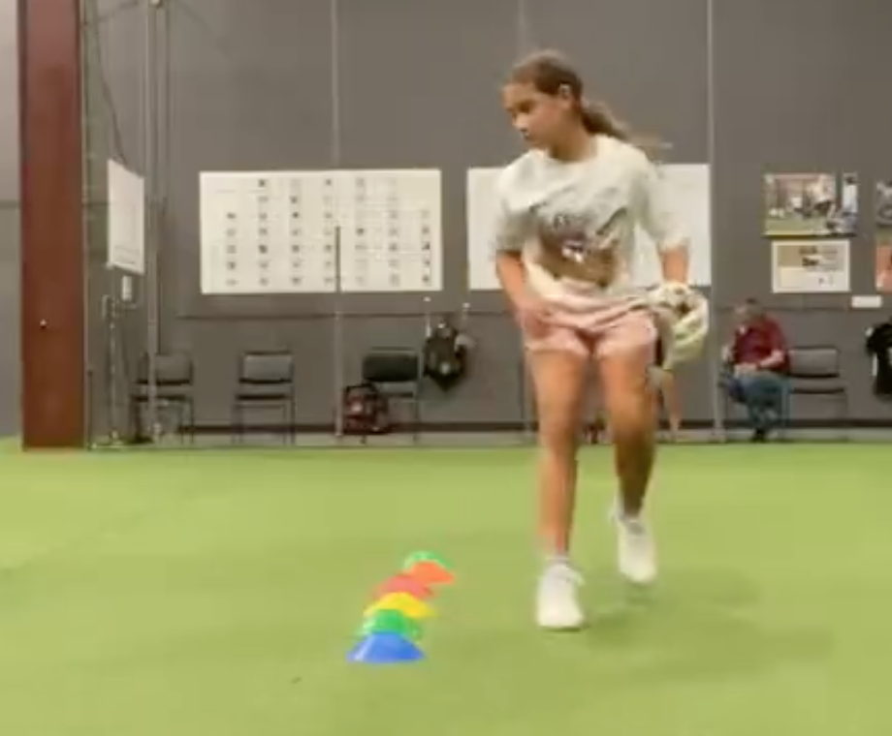  Station 1b: - Infield work - Hard Grounders (lines at SS, 2B) [10 minutes]  - Focus areas: field by attacking the ball  - Drill - Hard hit grounders to SS/2B; throw to bownet at 1B - Hit off tee to fielder, who fields & throws to 1B  - 3-4x time through each line and lines swap positions  - Mix in backhand and forehand sides  Station 3: Bunting (at home plate) [20 minutes]  - Technique: Stay in box where you normally are. Square up to the pitcher with both feet pointed to pitcher. Bent knees. When you turn, hands come forward and bat. Top hand is right below the barrel with a pinched grip between thumb and pointer finger. Need to be very strong with top hand. Barrel should be angled up about 30 degrees. As ball comes in, you bend down and level the bat. You want to hit the TOP HALF of the ball so the ball goes straight down. Keep eye on ball all the way through hitting the bat. Slight “punch” of the bat directed towards 3B (typically)  - Fingers’ pulled back from bat so they don’t get smashed  - Adjust height with knees not arms  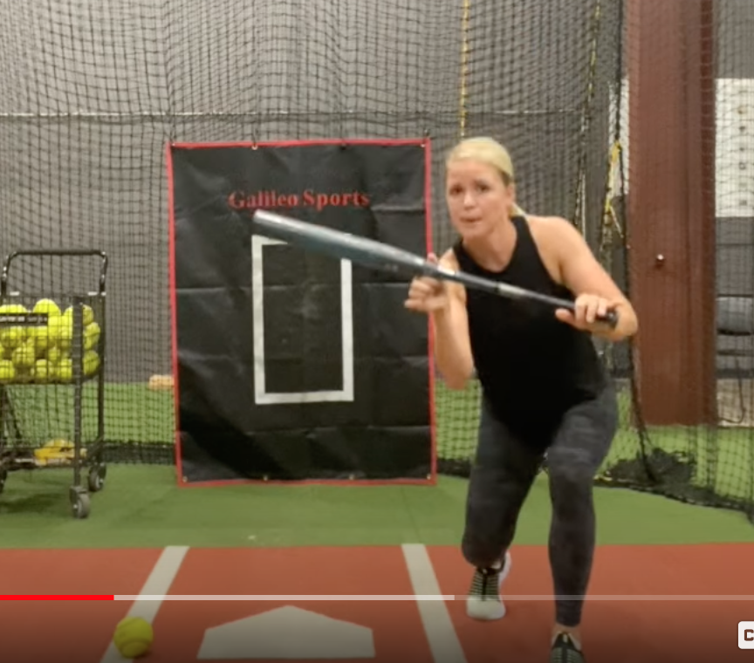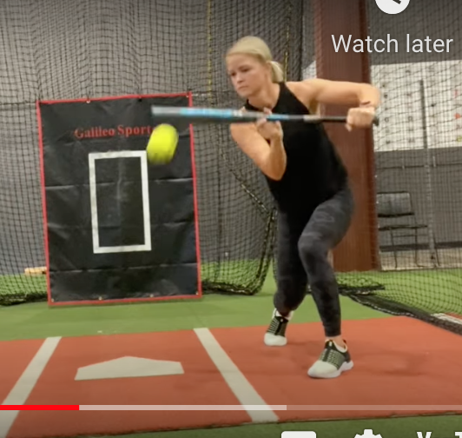  - Don’t bunt high balls. They will pop up to pitcher.  - Always down 1st or 3rd baseline. Never to pitcher  - Drills (if time)  - Pull Back. Line the kids up and coach pitches to them. Coach either pitches a hittable ball or puts it into the dirt. Player must pull back if coach throws a ball, otherwise it is a strike..  - Bunt Catch (not bat) - Player gets in good bunt position and catches tennis ball with back arm hand. Do not reach out!  - One Handed Top Hand Bunt - Set up in bunt position with only top (back) hand on the bat, bunt with just one hand.  - Full bunt from batting position (coach front toss)  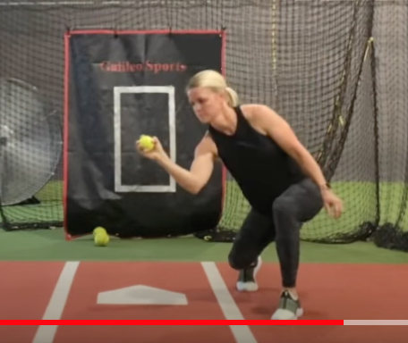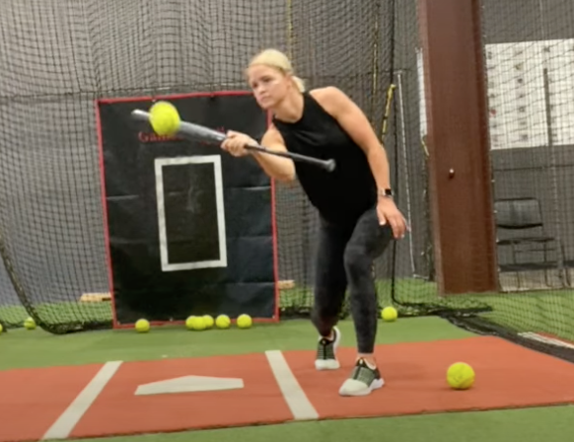
6:30 | Water Break
6:35  -  7:00 | Games!  - Total Bases Game  - 3 teams of 4 (2 hitting team + fielding team of 2 IF + 2 OF  - Hit off tee -> Count total bases advanced until ball reaches an IF securely.  - Spin & Hit - Spin around 2x with head on bat, then try to hit off tee

Practice #9
Time | Content
*Setup: Bownet near 1B; Cones & bucket in OF for the OF drill; Sliding pad
5:30-5:40 | Warmups  - Knee Hugs  - Monster Walks  - Lunge Twists  - Spidermans  - Figure 4s  - Quad Pulls + Dancers  - Arm Circles  - Arm bar stretches across torso  - Shoulder internal & external rotations (U shapes)
5:40-5:50 | Throwing progression - Two lines - 8’ apart (or one line at fence) - Pick 1-2  - Warmups & Activations  - Simple Scap Pull (no throws)  - Kneeling Throw (into fence as team)  - Staggered Stance (into fence or to each other)  - Shuffle Throw (into fence or to each other)  - Hop Back | Backpedal Turn & Throw  - Pivot Throws  - Rocking Throw  - Kneeling Away Turn & Throw
5:50  -  6:05 | Crossfire Drill  - Have a player at 3B, SS, 2B and 1B positions. Backups 10 feet behind each player at each position. Evenly distribute backups behind each position (e.g. if 12 players, then 1 3B and 2 backups 10 feet behind 3B etc.)  - Need 2 coaches (C1 and C2). 8U to 10U they will roll balls  - Every player in normal fielding position, no cheating  - C2 hits ball to 3B who throws to 1B who covers 1st  - Independently C1 hits to either 2B or SS (mix it up) who then throws to  - other who covers 2nd  - Players at 1st or 2nd who catches ball either puts ball in bucket near base OR 1B throws to C2 and player on 2nd throws to C1  - After each player fields or catches, they go to end of the line at their position and backup takes position (ie 3B stays at 3B as backup)  - After each player gets 4 or 5 reps, then rotate (e.g. all 3Bs go to SS etc.)  - Continue rotation until all players have rotated to cover each base  - C2 may occasionally hit to 1B to keep 1B honest and not cheat  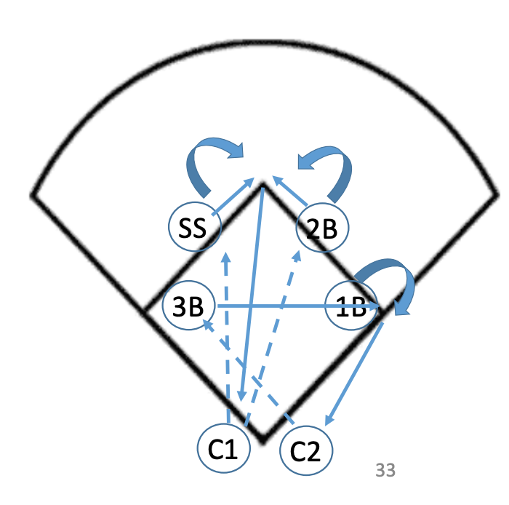
6:05 | Water Break
6:10  -  6:30 | Station A: Catchers at home plate  - Blocking with tennis balls Softball Catcher Skills: Blocking  - Framing: How To Receive And Frame Pitches  Station B: Outfield Drills in OF  - Station B1 in LF. Fly route - Two lines with two coaches. Place a cone 12 feet in front of each line.  - The player start running to the cone and makes a hard turn. The left line, breaks left, right line breaks right. Coach make a throw that the player catches on the run.  - Same, but a fade route. This video, https://youtu.be/8w6U8-c1wqY?t=52, from 0:52 to 0:55 shows the fade route  - Station B2 in CF. Jump over cones and then drop step  - https://www.youtube.com/watch?v=O5_YeW6d1OA  - Station B3 in RF. Two girls standing in OF side by side (simulate RC & RF) - Throw near/between them, have them call mine, one catch w/ other back up
6:30 | Water Break
6:35  -  7:00 | Batting  - PVC  - Top hand / bottom hand  - Hop back - work on hitting the ball with forward motion. The swing is both linear and rotational  - Pitching machine or cage

