8U Practice Season Long Practice Plan
V2.2 - Feb 2026

Practice #1
Time | Content
*Equipment needed: Name tag, Sharpie, 120 tennis balls, 1 small bucket for each player
*Setup: 8 tennis balls and 3 softballs in each bucket set along a line in OF
5:30 - 5:40 | Introduce Warmups  - 2 x run around the bases  - 10 second forward arm circles  - 10 second backward arm circles  - 10 second left/right arm deltoid stretches  - 10 second left/right arm tricep stretches  - 10 x squats  - 10 x lunge right leg  - 10 x lunge left leg  - 10 second left quad stretch  - 10 second right quad stretch  - 10 x cherry pickers
5:40 - 5:45 | Introductions  - Name game, favorite ice cream or other icebreaker  - Coach expectations: effort and attitude
5:45 - 5:55 | Demostrate How To Throw A Softball  - Softball Throwing Mechanics: Sequencing  - How To Throw A Softball  - Circle girls around coach  - Break down:  - Have all girls point their gloves towards their target. They stand facing 90 deg to their target.  - SuperGirl: Shoulder blade pinch. I love the idea of letting the girls pick their favorite super hero and using that as your command to pinch the should blades and make a U-shape with their arms.  - Ball to your ear  - Glove side foot takes a step  - Throw with elbow up and ball moving up and forward  Coaching Points:  - Focus on pinching shoulder blades. Scapula pull.  - Setting the shoulder in external rotation
  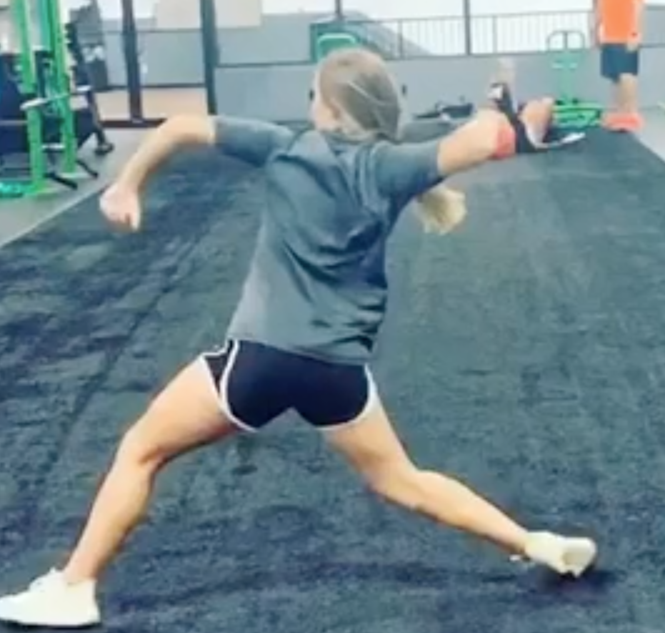  Scapula pull. Pinching shoulder blades | 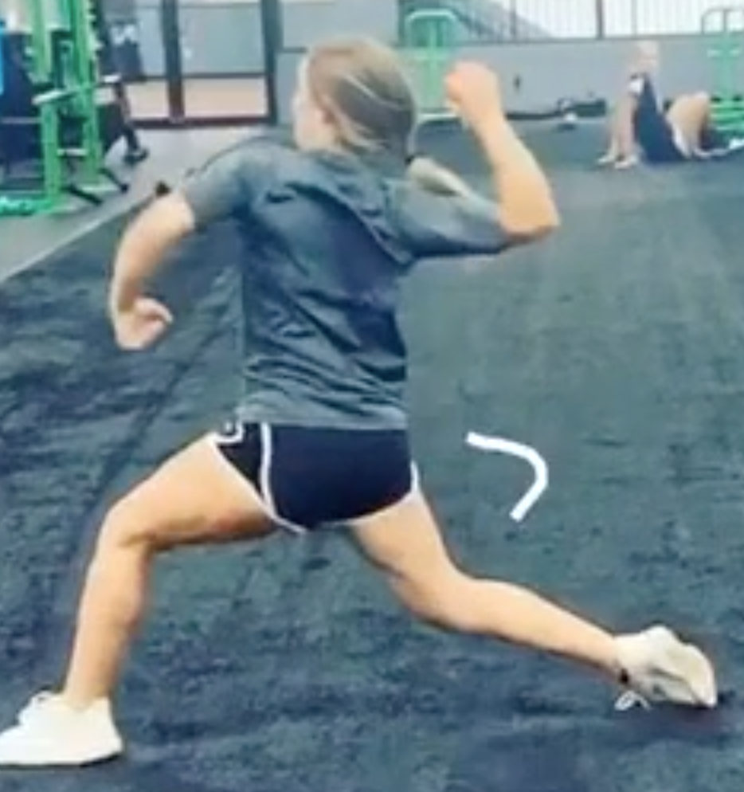  Shoulder external rotation
5:55  -  6:05 | Throw Tennis Balls  This is a good drill to get players a lot of throws when the players are not all proficient at throwing and catching.  - Distribute 8 tennis balls and 4 softballs into a small buckets for each player  - Have the players spread out down a line, about 6 feet between them  - Girl are oriented with left shoulder in the direction they will throw  - Coach says: Load (weight on back leg), SuperGirl, Throw.  - Girls all throw at the same time out into the field  - When everyone has thrown all their balls, the players take their bucket and go fetch 8 tennis balls and 4 softballs to throw again.
6:05  -  6:20 | Catch Tennis Balls How To Catch A Softball/Baseball For Beginners 3 Windshield Wiper Kids  - One line of kids with each coach  - Coach throws a tennis ball to a player without a glove  - The player catches the ball with their bare hand. Make sure they are catching with their glove hand.  - Game: See which line can catch the most tennis balls
6:20 | Water Break
6:25  -  6:35 | Demonstrate Fielding A Ground Ball Softball Infield Drills - Technique on How to Field a Groundball  Points to coach:  - Triangle between feet and glove  - Approach a ground ball as if you were an airplane coming in for a landing, vs a helicopter suddenly lowering itself  - Glove is a wall not a ramp  - Keep head down and watch ball all the way into glove
6:35  -  6:45 | Fielding Drill  Girls pair up facing each other in a line. They roll the ball to each other and practice fielding.  - Bare hand  - Glove
6:45  -  7:00 | Knock Out Game (split into 2 teams)  - Lineup teams along each baseline, so balls will be crossing each other  - Start behind baseline. Allowed to cross 2 steps in front of it.  - Throw it beyond midpoint and you are out  - Go until a team has won or 5 minutes whichever comes first

Practice #2
Time | Content
*Equipment: cones, 1x tee, 2x bownet, tennis balls
*Setup: 2xBownet, tennis balls in buckets
5:30 - 5:40 | Introduce Warmups  - 2 x run around the bases  - Hit inside bag  - Banana peel  - 10 second forward arm circles  - 10 second backward arm circles  - 10 second arm deltoid stretch  - 10 second arm tricep stretch  - 10 x squats  - 10 x lunge right leg  - 10 x lunge left leg  - 10 second left quad stretch  - 10 x cherry pickers
5:40  -  5:50 | Throw Tennis Balls  This is a good drill to get players a lot of throws when the players are not all proficient at throwing and catching.  - Distribute 8 tennis balls and 4 softballs into a small buckets for each player  - Have the players spread out down a line, about 6 feet between them  - Girl are oriented with left shoulder in the direction they will throw  - Coach says: Load, SuperGirl/Archer, Throw.  - Girls all throw at the same time out into the field  - When everyone has thrown all their balls, the players take their bucket and go fetch 8 tennis balls and 4 softballs to throw again.
5:50  -  6:00 | Catch Tennis Balls How To Catch A Softball/Baseball For Beginners 3 Windshield Wiper Kids  - One line of kids with each coach  - Coach throws a tennis ball to a player without a glove  - The player catches the ball with their bare hand. Make sure they are catching with their glove hand.  - Game: See which line can catch the most tennis balls
6:00 | Water Break
6:05  - 6:15 | Hitting Demonstration and Bat Safety  - Safety  - Set ground rules for when girls should swing bats (e.g. away from other players, only when instructed to do so by a coach)  - make sure they always swing bats with a helmet on  - Hitting Demonstration. How To Hit A Softball. This video covers too much for most 8U players. I simplify it down to:  - Hands  - If player is righty, right hand on top of bat  - Line up door knocking knuckles  - Feet:  - Feet outside hips, knees inside feet, slight knee bend, and slight bend at waist  - Toes, hips and shoulders should be facing plate  - Load  - Like in golf or tennis, to swing forward, you must first by going backwards with your swing  - As pitcher begins motion, begin to transfer weight back. Probably about 60% of weight is on back and 40% is on front  - Weight comes off front foot (i.e. slight heel lift) and is now more focused on inside of back leg  - Hip rotation initiated by back knee driving forward violently  - At point of contact top hand should be facing up, bottom hand facing down  - Follow through  Coaching points:  - Hip rotation is crucial  - Straight front leg  - Palm up/palm down at point-of-contact
6:15- 6:45 | Batting Stations  - Soft toss ​​Softball Hitting Drills & Must Know Batting Tips  - Tee Hitting Drill To Work On Staying Closed and Keeping Hands Through The Zone  - Live off coach pitch  - PVC station
6:45  -  7:00 | Queen of the Hill Game  - 3 pitches, you have to swing. Any contact keeps you in. Miss and you are out. Bad pitch then that’s bad luck. If you are out you go to the field.  - You can get back in by catching a pop-fly or by cleanly fielding a ball and making a throw to 1st base.  - Go to two pitches after first round, one pitch after second round.

Practice #3
Time | Content
*Equipment: cones, tee, 2x bownet, tennis balls, 4x buckets
*Setup: 2xBownet, tennis balls in buckets
5:30 - 5:40 | Introduce Warmups  - Run through 1st base. Coach stands beyond first to give player a high five. Emphasize running hard through the base.  - Run from 1st to 2nd. Explain 2nd and 3rd are “sticky” bases.  - 10 second forward arm circles  - 10 second backward arm circles  - 10 second arm deltoid stretch  - 10 second arm tricep stretch  - 10 x squats  - 10 x lunge right leg  - 10 x lunge left leg  - 10 second left quad stretch  - 10 x cherry pickers
5:40  -  5:50 | Throw Tennis Balls - Introduce Jab Step (stepping with their right foot at 45 degrees and then left foot comes forward so they are sideways)  This is a good drill to get players a lot of throws when the players are not all proficient at throwing and catching.  - Distribute 8 tennis balls and 4 softballs into a small buckets for each player  - Have the players spread out down a line, about 6 feet between them  - Girl are facing the direction they will throw  - Coach says: Load, Jab Step, SuperGirl/Archer, Throw.  - Girls all throw at the same time out into the field  - When everyone has thrown all their balls, the players take their bucket and go fetch 8 tennis balls and 4 softballs to throw again.
5:50  -  6:00 | Demonstrate Fielding A Ground Ball Softball Infield Drills - Technique on How to Field a Groundball  Points to coach:  - Triangle between feet and glove  - Approach a ground ball as if you were an airplane coming in for a landing, vs a helicopter suddenly lowering itself  - Glove is a wall not a ramp  - Keep head down and watch ball all the way into glove
6:00  -  6:20 | Snake Drill Infield Training and Drills for All Levels  4 buckets, coach on knee next to bucket. Girls field and place ball in bucket. Coaches are triangles, circles are buckets, circles w/X are starting pts for girls.  Coach rolls the ball. Player fields it and either puts it into the bucket or throws back to coach. Then they run around bucket and field a ball rolled to them from the coach at the next buck.  Progression:  - Charge the ball, field it, and put it into the bucket  - Remind them, right, left, field, and put it into the bucket  - Field the ball, jab step, and throw to coach  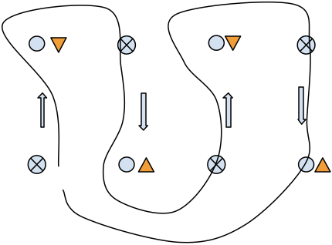
6:20 | Water Break
6:25  -  6:45 | Batting Stations  - Soft toss ​​Softball Hitting Drills & Must Know Batting Tips  - Tee Hitting Drill To Work On Staying Closed and Keeping Hands Through The Zone  - Live off coach pitch
6:45  -  7:00 | Relay Game  - 2 lines girls spaced about 10 feet apart  - It is race to throw the ball down the line and back  Coaching points  - Make sure they pivot to their glove side

Practice #4
Time | Content
*Equipment: cones, tee, 2x bownet
*Setup: 2xBownet, tennis balls in buckets
5:30 - 5:40 | Introduce Warmups  - Run through 1st base. Coach stands beyond first to give player a high five. Emphasize running hard through the base.  - Run from 1st to 2nd. Explain 2nd and 3rd are “sticky” bases.  - 10 second forward arm circles  - 10 second backward arm circles  - 10 second arm deltoid stretch  - 10 second arm tricep stretch  - 10 x squats  - 10 x lunge right leg  - 10 x lunge left leg  - 10 second left quad stretch  - 10 x cherry pickers
5:40  -  5:50 | Throw Tennis Balls  This is a good drill to get players a lot of throws when the players are not all proficient at throwing and catching.  - Distribute 8 tennis balls and 4 softballs into a small buckets for each player  - Have the players spread out down a line, about 6 feet between them  - Girl are facing the direction they will throw  - Coach says: Load, Jab Step, SuperGirl/Archer, Throw.  - Girls all throw at the same time out into the field  - When everyone has thrown all their balls, the players take their bucket and go fetch 8 tennis balls and 4 softballs to throw again.
5:50  -  6:10 | Know the play  - Split team into fielders and runners. Assign the fielders positions. Pick a second year / confident player for 1B.  - Runners wear helmets  - Coach rolls ball to different positions  - Fielders make play. Yell “freeze” to give direction after a play.  - Rotate positions  Coaching points  - Remind the girls what a force out is  - It is a race between the fielders getting the ball to a base vs the runner forced to that base  - Runner goes through 1B without slowing down
6:10  -  6:34 | Divide the team into two groups. 12 minutes at each station  Station #1 in IF - The Force Out  Introduce the force out at 2B and 3B. Many outs can be made by simply fielding the ball and stepping on a base.  - Runner with helmet starts running on coach command  - Coach rolls ball  - Fielders try to get an out either by throwing to 1st or stepping on their own base.  Station #2 in OF. Pop-flies  - Demonstrate catching pop-fly.  - Making sure they’re catching above their head, not doing the bucket catch at waist height  - Start with soft or whiffle balls and very low, easy pop-flies. Build their confidence. Only increase height as they are individually able.
6:20 | Water Break
6:25  -  6:45 | Batting Stations  - PVC pipe  - Tee Hitting Drill To Work On Staying Closed and Keeping Hands Through The Zone  - Live off coach pitch
6:45  -  7:00 | Head / Knees / Ankles / Ball Game  - Have girls pair up and kneel across from each other with a single ball between each pair  - Coach says one of the following: “Head” “Knees” “Ankles” or “Ball”  - Players move their hands to wherever the coach says until the coach says “Ball” at which point they each try and grab the ball.  - Do 3-4 rounds and then have one side of girls move down so partners always switch

Practice #5
Time | Content
*Equipment: cones, tee, 2x bownet, 4x buckets
5:30 - 5:40 | Introduce Warmups  - Run through 1st base. Coach stands beyond first to give player a high five. Emphasize running hard through the base.  - Run from 1st to 2nd. Explain 2nd and 3rd are “sticky” bases.  - 10 second forward arm circles  - 10 second backward arm circles  - 10 second arm deltoid stretch  - 10 second arm tricep stretch  - 10 x squats  - 10 x lunge right leg  - 10 x lunge left leg  - 10 second left quad stretch  - 10 x cherry pickers
5:40  -  5:50 | Throw Tennis Balls - Re-Introduce Jab Step  This is a good drill to get players a lot of throws when the players are not all proficient at throwing and catching.  - Distribute 8 tennis balls and 4 softballs into a small buckets for each player  - Have the players spread out down a line, about 6 feet between them  - Girl are facing the direction they will throw  - Coach says: Load, Jab Step, Archer, Throw.  - Girls all throw at the same time out into the field  - When everyone has thrown all their balls, the players take their bucket and go fetch 8 tennis balls and 4 softballs to throw again.
5:50  -  6:00 | Demonstrate Fielding A Ground Ball Softball Infield Drills - Technique on How to Field a Groundball  Points to coach:  - Triangle between feet and glove  - Approach a ground ball as if you were an airplane coming in for a landing, vs a helicopter suddenly lowering itself  - Glove is a wall not a ramp  - Keep head down and watch ball all the way into glove
6:00  -  6:20 | Snake Drill Infield Training and Drills for All Levels  Three buckets at A, B, C. One coach at each bucket. Coach at bucket A rolls ball to player at first. Play make a jab step and throws it back. Then they run around bucket A and field a ball rolled to them from the coach at B. Player fields the ball throws to coach and runs around bucket at B. Coach at C rolls ball. They field the ball and throw back to coach. They then run around bucket C and all the way around 2nd to first base.
6:20 | Water Break
6:25  -  6:45 | Batting Stations  - Soft toss ​​Softball Hitting Drills & Must Know Batting Tips  - Tee Hitting Drill To Work On Staying Closed and Keeping Hands Through The Zone  - Live off coach pitch
6:45  -  7:00 | Knock Out Game (split into 2 teams of 6 or 7 girls)  - Lineup teams along each baseline, so balls will be crossing each other  - Start behind baseline. Allowed to cross 2 steps in front of it.  - Throw it beyond midpoint and you are out  - Go until a team has won or 5 minutes whichever comes first  - Winners take on the coaches, everyone else cheers on

Practice #6
Time | Content
*Equipment: cones, tee, 2x bownet
*Setup: 2xBownet, tennis balls in buckets
5:30 - 5:40 | Introduce Warmups  - 2 x run around the bases  - Hit inside bag  - Banana peal  - 10 second forward arm circles  - 10 second backward arm circles  - 10 second arm deltoid stretch  - 10 second arm tricep stretch  - 10 x squats  - 10 x lunge right leg  - 10 x lunge left leg  - 10 second left quad stretch  - 10 x cherry pickers
5:40  -  5:50 | Throw Tennis Balls  This is a good drill to get players a lot of throws when the players are not all proficient at throwing and catching.  - Distribute 8 tennis balls and 4 softballs into a small buckets for each player  - Have the players spread out down a line, about 6 feet between them  - Girl are facing the direction they will throw  - Coach says: Load, Jab Step, Archer, Throw.  - Girls all throw at the same time out into the field  - When everyone has thrown all their balls, the players take their bucket and go fetch 8 tennis balls and 4 softballs to throw again.
5:50  -  6:00 | Backhand/Forehand Fielding Drill  - Five cones for each girl  - Lead girls through motion  - Normal  - Closed forehand  - Drop step forehand  - Reset  - Closed backhand  - Drop step backhand
6:00  -  6:20 | Fielding Drill  Girls pair up in line facing each other. They roll the ball to each other and practice fielding.  - Bare hand  - Glove  - Bounce  - Glove side  - Backhand  - With mit, field ball, then drop it and use throwing hand to pick
6:20 | Water Break
6:25  -  6:45 | Batting Stations  - Soft toss ​​Softball Hitting Drills & Must Know Batting Tips  - Tee Hitting Drill To Work On Staying Closed and Keeping Hands Through The Zone  - Coach pitch
6:45  -  7:00 | Head / Knees / Ankles / Ball Game  - Have girls pair up and kneel across from each other with a single ball between each pair  - Coach says one of the following: “Head” “Knees” “Ankles” or “Ball”  - Players move their hands to wherever the coach says until the coach says “Ball” at which point they each try and grab the ball.  - Do 3-4 rounds and then have one side of girls move down so partners always switch

Practice #7
Time | Content
*Equipment: cones, tee, 2x bownet
5:30 - 5:40 | Introduce Warmups  - 2 x run around the bases  - Hit inside bag  - Banana peal  - 10 second forward arm circles  - 10 second backward arm circles  - 10 second arm deltoid stretch  - 10 second arm tricep stretch  - 10 x squats  - 10 x lunge right leg  - 10 x lunge left leg  - 10 second left quad stretch  - 10 x cherry pickers
5:40  -  5:50 | Evaluate Throwing Abilities  - This is a good drill to evaluate throwing ability before your first game. The players self sort themselves by throwing ability.  - All players line up between 1st and 2nd  - Coach rolls a ball from home  - Player fields it and throws it to a coach at 1st. Good throw? They go to SS. Bad throw? They go back to the end of the line.  - Players at SS throw to a coach at home. Good throw? Go to 3rd. Bad throw? Go to end of line at SS.  - At 3B throw to 1st
5:50 | Water Break
5:55  -  6:25 | Two groups. 15 minutes at each station  Station #1 in IF. Situations - The Force Out  - Three ways to make outs  - Force out  - Tag out  - Catch a pop fly  - Force out  - It is a race between the batter-runner and the fielders to get the ball to 1st  - Place players in the infield  - One coach rolls a ball to the fielders who try to make the out at 1st. Another coach is the runner.  Station #2 in OF. Pop-flies  - Demonstrate catching pop-fly.  - Making sure they’re catching above their head, not doing the bucket catch at waist height  - Start with soft or whiffle balls and very low, easy pop-flies. Increase
6:25  -  6:45 | Batting Stations  - Soft toss ​​Softball Hitting Drills & Must Know Batting Tips  - Tee Hitting Drill To Work On Staying Closed and Keeping Hands Through The Zone  - Live off coach pitch
6:45  -  7:00 | Relay Game

Practice #8
Time | Content
*Equipment: cones, tee, 2x bownet
5:30 - 5:40 | Introduce Warmups  - 2 x run around the bases  - Hit inside bag  - Banana peal  - 10 second forward arm circles  - 10 second backward arm circles  - 10 second arm deltoid stretch  - 10 second arm tricep stretch  - 10 x squats  - 10 x lunge right leg  - 10 x lunge left leg  - 10 second left quad stretch  - 10 x cherry pickers
5:40  -  5:50 | Pitching / Catching  - How to Pitch a Softball  - Catching blocking basics  - How to receive a pitch (catching)  Station #1. Pitching  - C grip  - T  - Ball facing out behind  - Throw at hip  - Point Elbow  - K  - Step. Left foot pointed to 3rd base  - Whole pitch  - Right foot forward, Hands apart  - Rock back, hands together  - Pivot to T  - Big clock all the way through  Station #2. Catching Basics from videos above
5:50 | Water Break
5:55  -  6:25 | Situations  - 3 groups: 1 group as runners, other two groups in the field  - - Ball to 2nd  - - Who covers 2nd?  - - Ball to SS  - - Who covers 2nd? if 2nd forgets center field covers 2nd.  - - Ball to 1st  - - Who covers 1st?  - - Ball to pitcher  - - Jog to first and under hand  - - Ball to Center field  - Relay in
6:25  -  6:45 | Batting Stations  - Soft toss ​​Softball Hitting Drills & Must Know Batting Tips  - Tee Hitting Drill To Work On Staying Closed and Keeping Hands Through The Zone  - Live off coach pitch
6:45  -  7:00 | Queen of the Hill Game

Practice #9
Time | Content
*Equipment: cones, tee, 2x bownet
5:30 - 5:40 | Introduce Warmups  - 2 x run around the bases  - Hit inside bag  - Banana peal  - 10 second forward arm circles  - 10 second backward arm circles  - 10 second arm deltoid stretch  - 10 second arm tricep stretch  - 10 x squats  - 10 x lunge right leg  - 10 x lunge left leg  - 10 second left quad stretch  - 10 x cherry pickers
5:40  -  5:50 | More Advanced Throwing Drills - Pick 2-3 drills  - Warmups & Activations  - Simple Scap Pull (no throws)  - Kneeling Throw (into fence as team)  - Staggered Stance (into fence or to each other)  - Shuffle Throw (into fence or to each other)
5:50 | Water Break
5:55  -  6:25 | Two groups. 15 minutes at each station  Station #1 in IF. Ball, Base, Backup  - Four lines at SS, 2B, and CF  - Coach rolls ball to SS  - 2B runs to 2nd  - CF run in line with the throw to 2nd to backup  - SS throw ball to 2B  Station #2 in OF. Fly routes  - Two lines with two coaches  - Put a cone 20 feet away from the each line  - Two routes:  - Run route with a ninety degree turn at the cone  - Run route that fades after the cone
6:25  -  6:45 | Batting Stations  - Soft toss ​​Softball Hitting Drills & Must Know Batting Tips  - Tee Hitting Drill To Work On Staying Closed and Keeping Hands Through The Zone  - Live off coach pitch
6:45  -  7:00 | Knock Out Game (split into 2 teams of 6 or 7 girls)  - Lineup teams along each baseline, so balls will be crossing each other  - Start behind baseline. Allowed to cross 2 steps in front of it.  - Throw it beyond midpoint and you are out  - Go until a team has won or 5 minutes whichever comes first  - Winners take on the coaches, everyone else cheers on

Practice 10
Time | Content
*Equipment: cones, tee, 2x bownet
5:30  - 5:45 | Warmups  - 5 min - Warmup  - 10 min - Throwing progression
5:45  -  6:05 | Fast Footwork, Strong Fielding, Fast Good Throws. Explain how crucial footwork is to fast fielding: “Right left field, right left throw”. Need to be on your toes and ready to move fast  Fielding Drill [bownet at 1st]  6 minutes each station  Three drills in parallel at 3rd, 2nd, 1st:  - Drill #1 Two cones about 10 feet apart. Stutter step from back cone to front cone. Player continues to stutter step. Coach rolls ball, player fields it and gets into throwing position with arms pulled back and elbows up. Softball Infield Drills- Footwork & Body Control  - Drill #2 Hop over line of cones and coach rolls a ball. Softball Infield Drills- Footwork and Direction  - Drill #3 Shuffle between two cones - start at right cone shuffle in ready position to and touch left cone,coach rolls ball when they touch cone to the right of the right cone. Softball Infield Drills- Side to Side Shuffle & Throw
6:05- 6:25, | Two groups  10 minutes each station  Station A: Ball, Base, Backup  - Lines 2B/SS/RC/LC  - Coach rolls a ball to 2B or SS; other one covers 2B  - Player make a throw to 2B  - RC and LC are backup and work on lining up with path of the ball if it is overthrown at 2B  Station B: Outfield crop hop -  - Jump out not up. Want to get as close to target as possible.  - Drill #1 3 hops on left leg then right, left, throw. Follow your throw. Like some one pushing you in the back. Two or three steps after the throw. Softball Outfield Drill - Crow Hop  - Drill #2 Fly route with drop step. Tuck glove. How To Drop Step In The Outfield  - Drill #3 Coach rolls ball, player field ball and crow hop. Glove and foot hit at same time.
6:25 | Water Break
6:30  -  7:00 | Batting Stations

Practice 11
Time | Content
*Setup: 12 x 5 little cones arranged between basepath and grass; line of two cones from home to 2nd
6:00 - 6:05 | Warmups  - 5 min - Warmups
6:05 - 6:20 | Throwing Drills - Pick 2-3 drills  - Warmups & Activations  - Simple Scap Pull (no throws)  - Kneeling Throw (into fence as team)  - Staggered Stance (into fence or to each other)  - Shuffle Throw (into fence or to each other)
6:20 - 6:30 | Backhand / forehand muscle memory.  Backhand / forehand video  5 cones for each player  Forehand, backhand, closed backhand, drop-step backhand, reset  Forehand, drop-step forehand, closed forehand, drop-step forehand, reset
6:30 - 6:45 | Backhand / forehand fielding drill. Girls pair up in line facing each other. They roll the ball to each other and practice fielding. [ Add cone arrangement ]  - Bare hand  - Glove  - Bounce  - Glove side  - Backhand  - With mit, field ball, then drop it and use bare throwing hand to pick
6:45 | Water Break
6:50 - 7:10 | Relay/Cut-off drill  - Cut 2 from RF. Girls are divided between SS, 2, RC.  - Coach throws ball into outfield.  - 2nd is cut. Arms up, “ball, ball, ball”  - SS covers 2nd and yells instructions “left”, “right”, “stop” to create straight line between 2nd base, 2nd basemen, and outfield player with the ball. Throw to second through relay. Then introduce a runner at home that goes on the throw.  - Cut 2 from LF. Girls are divided between SS, 2, LC.  - Coach throws ball into outfield.  - SS is cut. Arms up, “ball, ball, ball”  - 2 covers 2nd and yells instructions “left”, “right”, “stop” to create straight line between 2nd base, 2nd basemen, and outfield player with the ball. Throw to second through relay. Then introduce a runner at home that goes on the throw.  - Cut 3 from LF. Girls are divided between SS, 2, LC.  - Coach throws ball into outfield.  - SS is cut. Arms up, “ball, ball, ball”  - 2 covers 2nd and yells instructions “left”, “right”, “stop” to create straight line between 3rd base, SS, and outfield player with the ball. Throw to third through relay. Then introduce a runner at home that goes on the throw.
7:10 - 7:40 | Situations.  Three teams. Bat for 10 minutes then switch
7:40  -  8:00 | Relay Game  - 2 lines girls spaced about 10 feet apart  - It is race to throw the ball down the line and back  Coaching points  - Make sure they pivot to their glove side

