6U Practice Season Long Practice Plan
V2.2 - Feb 2026

Practice #1
Time | Content
*Safety As the kids arrive, always hang their bats up high on the backstop, where the players can’t reach them. You don’t want five year olds swinging aluminum sticks around when you are watching
*Equipment needed: Name tag, Sharpie, 120 tennis balls, 1 small bucket for each player
*Setup: 10 tennis balls in each bucket set along a line in OF
5:00 - 5:10 | Introduce Warmups  - Run through 1B  - Have a coach beyond first base to give them a high five  - Make sure they run through the base  - Run to 2B  - 2B is “sticky” base  - They need to keep a foot on the base to be “safe”  - Run to 3B and finally home  - 10 second forward arm circles  - 10 second backward arm circles  - 10 x jumping jacks  - 10 x cherry pickers
5:10 - 5:15 | Introductions  - Name game, favorite ice cream or other icebreaker
5:15  -  5:17 | Safety talk  - Bat safety. Only pick up a bat when instructed by a coach.  - Hold bat with head on ground. Don’t swing it around. You don’t want to hurt one of your friends.
5:17  -  5:20 | The Game  - Each team takes turns being fielders and hitters.  - When the batter hits the ball, she runs around the bases and if she can go all the way around, her team gets a point.  - However, the fielders can put the batter out if they can get the ball to 1st base before the base runner steps a foot on 1st base.  - The game is a race between the batters and the fielders.
5:20 - 5:25 | Demonstrate How To Throw A Softball  - Softball Throwing Mechanics: Sequencing | High Level Throwing on Vimeo and How To Throw A Softball  - Circle girls around coach  - Have all girls point their gloves towards their target, standing 90 deg to their target.  - SuperGirl: Shoulder blade pinch. I love the idea of letting the girls pick their favorite super hero (SuperGirl) and using that as your command to pinch the shoulder blades and make a U-shape with their arms. Pull the elbows back to make a U-shape. Pinch your shoulder blade like pulling an arrow back in a bow.  - Glove side foot takes a step  - Throw  Coaching points:  - Ensure their shoulder blades are pinching back to make the U-shape  - After pinch, put shoulder into external rotation  - Elbow leads the throw. Ensure their elbow stays at or slightly below their shoulder. If the elbow dips way down it will create a push throw.  - Future practice will add the 45 degree jab step to pivot
  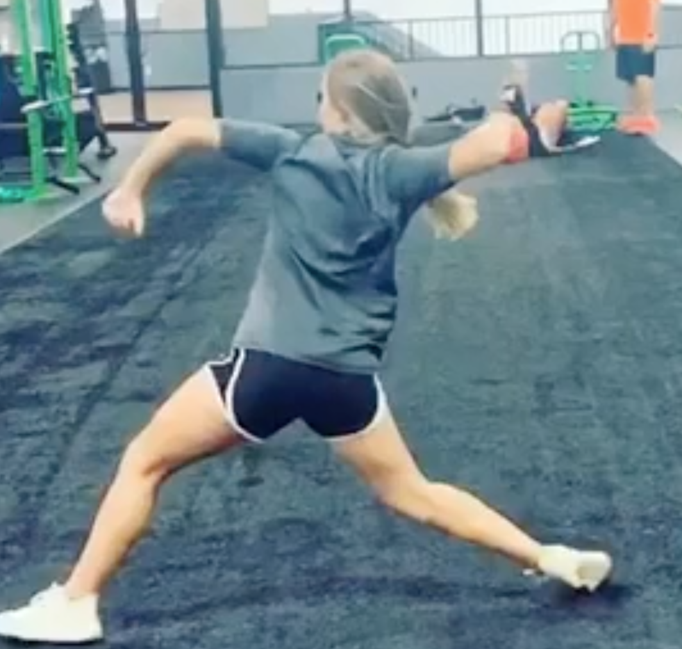  Scapula pull. Pinching shoulder blades | 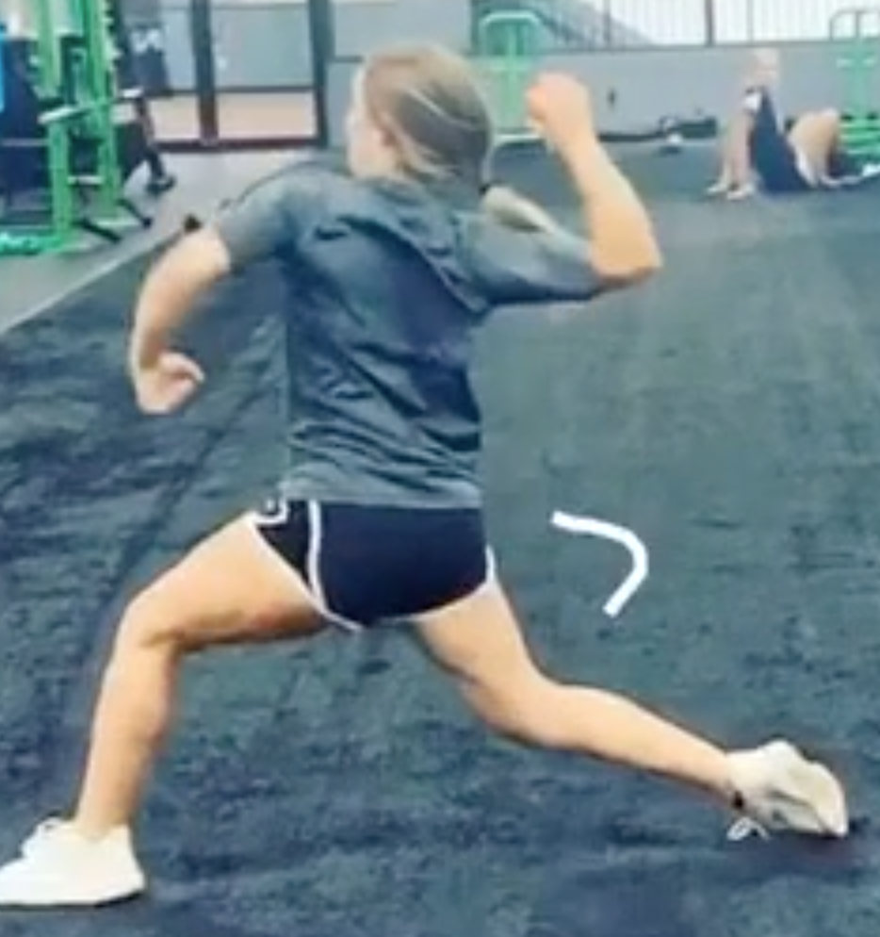  Shoulder external rotation
5:25  -  5:35 | Throw Tennis Balls  This is a good drill to get players a lot of throws when the players are not all proficient at throwing and catching.  - Distribute 8 tennis balls and 4 softballs into a small buckets for each player  - Have the players spread out down a line, about 6 feet between them  - Girl are oriented with left shoulder in the direction they will throw  - Coach says: Load, Transfer, SuperGirl, Throw.  - Girls all throw at the same time out into the field  - When everyone has thrown all their balls, the players take their bucket and go fetch 8 tennis balls and 4 softballs to throw again.
5:35 | Water Break
5:40  -  5:45 | Demonstrate Fielding A Ground Ball Softball Infield Drills - Technique on How to Field a Groundball  Points to coach:  - Triangle between feet and glove  - Approach a ground ball as if you were an airplane coming in for a landing, vs a helicopter suddenly lowering itself  - Glove is a wall not a ramp  - Keep head down and watch ball all the way into glove
5:45  -  5:55 | Fielding Drill  - Girls line up in as many lines as coaches  - Coach rolls a ball and the player fields the ball  - First 3 times they move their feet so the ball rolls between their legs  - Next 3 times, they field the ball and throw back to coach  - Next 3 times, remind them to charge the ball  - Finally, have a race between the lines to see who can cleanly field the most balls in 2 minutes
5:55  -  6:00 | Double Diamond Relay (split into 2 teams)  - One team and coach at Home, the other team and a coach at 2B  - 1st team runs from Home, 1B, 2B, 3B, back to Home  - 2nd team runs from 2B, 3B, Home, 1B, back to 2B  - Relay race, if odd number of kids have one player run twice

Practice #2
Time | Content
*Equipment: 2xBownet, tennis balls, small buckets
*Setup: Place 8 tennis balls and 3 softballs in each bucket and space them out down a line
5:00 - 5:05 | Introduce Warmups  - Run through 1B  - Have a coach beyond first base to give them a high five  - Make sure they run through the base  - Run to 2B  - 2B is “sticky” base  - They need to keep a foot on the base to be “safe”  - Run to 3B and finally home  - 10 second forward arm circles  - 10 second backward arm circles  - 10 x jumping jacks  - 10 x cherry pickers
5:05  -  5:20 | Know the play  - Split team into fielders and runners. Assign the fielders positions. Pick a second year / confident player for 1B.  - Runners wear helmets  - Coach rolls ball to different positions and runner runs through 1B  - Fielder throws to 1B  - Rotate positions  Coaching points  - Remind the girls what a force out is  - It is a race between the fielders getting the ball to 1B vs the runner  - Runner goes through 1B without slowing down
5:20 | Water Break
5:25  -  5:35 | Hitting Demonstration and Bat Safety  - Safety  - Set ground rules for when girls should swing bats (e.g. away from other players, only when instructed to do so by a coach)  - Players must wear a helmet while swing a bat  - Hitting Demonstration. How To Hit A Softball. This video covers too much for most 8U players. I simplify it down to:  - Hands  - If player is righty, right hand on top of bat  - Line up door knocking knuckles  - Bat a 45 degree angle  - Feet:  - Feet outside hips, knees inside feet, slight knee bend, and slight bend at waist  - Toes, hips and shoulders should be facing plate  - Load  - Like in golf or tennis, to swing forward, you must first by going backwards with your swing  - As pitcher begins motion, begin to transfer weight back. About 60% of weight is on back and 40% is on front  - Weight comes off front foot (i.e. slight heel lift) and is now more focused on inside of back leg  - Hip rotation initiated by back knee driving forward violently.  - Front leg straight  - At point of contact top hand should be facing up, bottom hand facing down  - Follow through
5:35- 5:50 | Batting Stations  - As many stations as coaches or parents. One bownet and tee at each station. Have player repeat hands, feet, load, then have them slowing bring the bat to contact and freeze. Then reset and hit the ball. https://www.instagram.com/p/CP8iaOdA9wA/  - Coach pitch. It is best to pick one coach to pitch to the girls; the timing will be different for each coach. Pick the coach that can hit their bat. I am tall, so I start on one knee, throwing near the ground, so they hit the ball at its apex.
5:50  -  6:00 | Queen of the Hill Game  - Each batter gets 3 pitches, they have to swing. Any contact keeps them in - go to the back of the batting line. Miss and they’re out - grab your glove and go to the field. Bad pitch, too bad, that’s bad luck.  - You can get back in by catching a pop-fly or by cleanly fielding a ball and making a throw to 1B.  - After the first round, reduce to two pitches; one pitch after the second round.

Practice #3
Time | Content
*Equipment: 2xBownet, tennis balls, small buckets
*Setup: Place 8 tennis balls and 3 softballs in each bucket and space them out down a line
5:00 - 5:05 | Introduce Warmups  - Run through 1st base. Coach stands beyond first to give player a high five. Emphasize running hard through the base.  - Run from 1st to 2nd. Explain 2nd and 3rd are “sticky” bases.  - 10 second forward arm circles  - 10 second backward arm circles  - 10 x jumping jacks  - 10 x cherry pickers
5:05  -  5:20 | Throw Tennis Balls - Introduce Jab Step  This is a good drill to get players a lot of throws when the players are not all proficient at throwing and catching. The Jab Step is a 45 degree step by the throwing fvv that allows the hips and shoulder to rotate into line with target.  - Distribute 8 tennis balls and 4 softballs into a small buckets for each player  - Have the players spread out down a line, about 6 feet between them  - Girl are facing the direction they will throw  - Coach says: Load, Transfer, Jab Step, SuperGirl, Throw.  - Reminder: SuperGirl is their indicator to pinch their shoulder blades and bring their arms into a U-shape  - Girls all throw at the same time out into the field  - When everyone has thrown all their balls, the players take their bucket and go fetch 8 tennis balls and 4 softballs to throw again.
5:25  -  5:30 | Catch Tennis Balls How To Catch A Softball/Baseball For Beginners 3 Windshield Wiper Kids  - One line of kids with each coach  - Coach throws a tennis ball to a player without a glove  - The player catches the ball with their bare hand. Make sure they are catching with their glove hand.  - Game: See which line can catch the most tennis balls
5:30 | Water Break
5:30  -  5:35 | Demonstrate Fielding A Ground Ball Softball Infield Drills - Technique on How to Field a Groundball  Points to coach:  - Triangle between feet and glove  - Approach a ground ball as if you were an airplane coming in for a landing, vs a helicopter suddenly lowering itself  - Glove is a wall not a ramp  - Keep head down and watch ball all the way into glove
5:40  -  5:50 | Fielding Drill  As many lines as coaches. Roll the ball to the player. She fields the ball and throws it back to the coach.  - Get the glove all the way to the ground  - Eye on the ball all the way into the glove  - Charge the ball. Land like an airplane, not a helicopter
5:50  -  6:00 | Knock Out Game (split into 2 teams of 6 or 7 girls)  - Lineup teams along each baseline, so balls will be crossing each other  - Start behind baseline. Allowed to cross 2 steps in front of it.  - Throw it beyond midpoint and you are out  - Go until a team has won or 5 minutes whichever comes first  - Winners take on the coaches, everyone else cheers on

Practice #4
Time | Content
*Equipment: 2xBownet, milk jugs with coaches’ faces
*Setup: milk jugs on buckets
5:00 - 5:10 | Introduce Warmups  - Run through 1B  - Have a coach beyond first base to give them a high five  - Make sure they run through the base  - Run to 2B  - 2B is “sticky” base  - They need to keep a foot on the base to be “safe”  - Run to 3B and finally home  - 10 second forward arm circles  - 10 second backward arm circles  - 10 x jumping jacks  - 10 x cherry pickers
5:10  -  5:20 | Throw At The Coach’s Face  Bring 3 milk jugs with an inch of water in them. On the outside, paste a picture of the coach’s face. Ham it up about how much it hurts when they hit the milk jug.  Set up three stations with a milk jug on a bucket. About 15 feet away from the milk jug place a cone for the kids to throw from and a further cone for the line
5:20  -  5:30 | Fielding Drill  Girls pair up facing each other in a line. They roll the ball to each other and practice fielding.  - Bare hand  - Glove  - Bounce  - With mit, field ball, then drop it and use throwing hand to pick
5:30 | Water Break
5:35  -  5:50 | Batting Stations  - PVC station  - Hitting Drill To Engage The Hips  - 3 SIMPLE Hitting Drills With PVC To Improve Body Control - Hip Activation - Baseball Hitting Tips  - Tee - after the player hits the ball, have them count to three while keeping their eyes on the tee  - Live off coach pitch
5:50  -  6:00 | Queen of the Hill Game  - Each batter gets 3 pitches, they have to swing. Any contact keeps them in - go to the back of the batting line. Miss and they’re out - grab your glove and go to the field. Bad pitch, too bad, that’s bad luck.  - You can get back in by catching a pop-fly or by cleanly fielding a ball and making a throw to 1B.  - After the first round, reduce to two pitches; one pitch after the second round.

Practice #5
Time | Content
*Setup: 2xBownet
5:00 -  5:07 | Introduce Warmups  - 2x around the bases  - 10 second forward arm circles  - 10 second backward arm circles  - 10 x jumping jacks  - 10 x cherry pickers
5:07  -  5:10 | Discuss Outs  - Three ways to make outs  - Force out  - Tag out  - Catch a pop fly
5:10  -  5:30 | Divide the team into two groups. 10 minutes at each station  Station #1 in IF - The Force Out  Introduce the force out at 2B and 3B. Many outs can be made by simply fielding the ball and stepping on a base.  - Runner with helmet starts running on coach command  - Coach rolls ball  - Fielders try to get an out either by throwing to 1st or stepping on their own base.  Station #2 in OF. Pop-flies  - Demonstrate catching pop-fly.  - Making sure they’re catching above their head, not doing the bucket catch at waist height  - Start with soft or whiffle balls and very low, easy pop-flies. Build their confidence. Only increase height as they are individually able.
5:30 | Water Break
5:30  -  5:40 | Tagging Drill - https://funbaseball.wordpress.com/2013/08/27/tagging-drill/  Coaching points:  - Two hands when tagging with ball in glove
Batting Stations
- Soft toss ​​Softball Hitting Drills & Must Know Batting Tips
- Tee Hitting Drill To Work On Staying Closed and Keeping Hands Through The Zone
- Live off coach pitch
5:45  -  6:00 | Knock Out Game (split into 2 teams of 6 or 7 girls)  - Lineup teams along each baseline, so balls will be crossing each other  - Start behind baseline. Allowed to cross 2 steps in front of it.  - Throw it beyond midpoint and you are out  - Go until a team has won or 5 minutes whichever comes first  - Winners take on the coaches, everyone else cheers on

Practice #6
Time | Content
*Equipment: 2xBownet, stuff animal
*Setup: Place 8 tennis balls and 3 softballs in each bucket and space them out down a line
5:00 - 5:05 | Warmups  - 2x around the bases  - 10 second forward arm circles  - 10 second backward arm circles  - 10 x jumping jacks  - 10 x cherry pickers
5:05  -  5:15 | Hit the Stuffie  - Coach puts Tee on home plate, extend the Tee as far up as possible, and tie stuffed animal. Or stuffed animal on a bucket  - Girls line up at 3B position in single file line, while Coach is a bit to the right of home plate  - Coach rolls or hits ball to 3B position, girls field and then throw to H, trying to hit the stuffed animal  - Players hitting the stuffie get a point  - Player with most points win  - Helps girls focus on proper fielding and accurate throwing in a competitive but lighthearted environment
5:15 | Water Break
5:20  -  5:40 | Break into two teams  Mini-Game  - Only give the girls one pitch before bringing out the tee in order to keep the game moving.  - Yell “freeze” to explain a situation.
5:40  -  5:50 | Rock Around the Clock Game  - A one-on-one drill that can be done by a coach or parent  - Player lines up about 5-10 feet from Coach. Player should not move their feet for this drill  - Coach should throw the ball like a dart for better aim and less velocity. Key is straight throws and appropriate velocity for skill and age of player  - Coach first throws the ball at the player like a dart at 12 pm (ie near top of the head of the player). Player catches and soft tosses back to Coach  - Coach then throws the ball like a dart at 1pm, player catches, etc.  - Object of drill is to see how far around the clock the player can go, e.g. can they go all around the clock  - Goal of drill is to see if player can catch the ball in different locations around their body, as not all balls will be perfectly thrown to them when they are catching a ball (e.g. as a 1B)  - Coach should emphasize having the player treat their glove and catching elbow like a windshield wiper and also have the player figure when to switch their glove positions to underhand catches (e.g. for 4-6 pm for righty) and when to catch backhand (e.g. 7-8 pm for righty)
5:50  -  6:00 | Knock Out Game (split into 2 teams of 6 or 7 girls)  - Lineup teams along each baseline, so balls will be crossing each other  - Start behind baseline. Allowed to cross 2 steps in front of it.  - Throw it beyond midpoint and you are out  - Go until a team has won or 5 minutes whichever comes first  - Winners take on the coaches, everyone else cheers on

Practice #7
Time | Content
*Equipment: 2xBownet, tennis balls, small buckets
*Setup: Place 8 tennis balls and 3 softballs in each bucket and space them out down a line
5:30 - 5:40 | Introduce Warmups  - 2x around the bases  - 10 second forward arm circles  - 10 second backward arm circles  - 10 x jumping jacks  - 10 x cherry pickers
5:40  -  5:50 | Evaluate Throwing Abilities  - This is a good drill to evaluate throwing ability before your first game. The players self sort themselves by throwing ability.  - All players line up between 1st and 2nd  - Coach rolls a ball from home  - Player fields it and throws it to a coach at 1st. Good throw? They go to SS. Bad throw? They go back to the end of the line.  - Players at SS throw to a coach at home. Good throw? Go to 3rd. Bad throw? Go to end of line at SS.  - At 3B throw to 1st
5:50 | Water Break
5:55  -  6:25 | Two groups. 15 minutes at each station  Station #1 in IF. Ball, Base, Backup  - Four lines at SS, 2B, and CF  - Coach rolls ball to SS  - 2B runs to 2nd  - CF run in line with the throw to 2nd to backup  - SS throw ball to 2B  Station #2 in OF. Fly routes  - http://www.mysoftballcoach.com/fly-ball.html  - Two lines with two coaches  - Put a cone 12 feet away from the each line  - Two routes:  - Run route with a ninety degree turn at the cone  - Run route that fades after the cone
6:25  -  6:45 | Batting Stations  - Soft toss ​​Softball Hitting Drills & Must Know Batting Tips  - Tee Hitting Drill To Work On Staying Closed and Keeping Hands Through The Zone  - Live off coach pitch
6:45  -  7:00 | “Beat Me if You Can” Game  - This is a game that is a competition between the base runner and the infield  - Have a player at each infield position except pitcher (and yes include Catcher who should wear helmet). They must be playing their position, no cheating and camping out on the bases  - Have extra players act as baserunners (must wear helmets!)  - Have Runner 1 a few feet away from home plate (safely away from coach hitting or rolling) and rest of Runners out of the field of play  - Coach 1 hits or rolls the ball to SS (make sure Catcher won’t get hit)  - Once the SS touches the ball, Runner 1 goes around all bases  - SS throws to 1B who covers 1st, who throws to 2B covering 2nd, who throws to 3B covering 3rd, who throws to catcher at home  - Runner wins if they get to home before being thrown out at home; infield wins if Catcher tags home plate before runner crosses home  - Next runner comes up and repeat  - Rotate/swap out infielders with runners after few iterations  - Key is learning base running but also importance of throwing ball accurately and catching the ball while covering a base  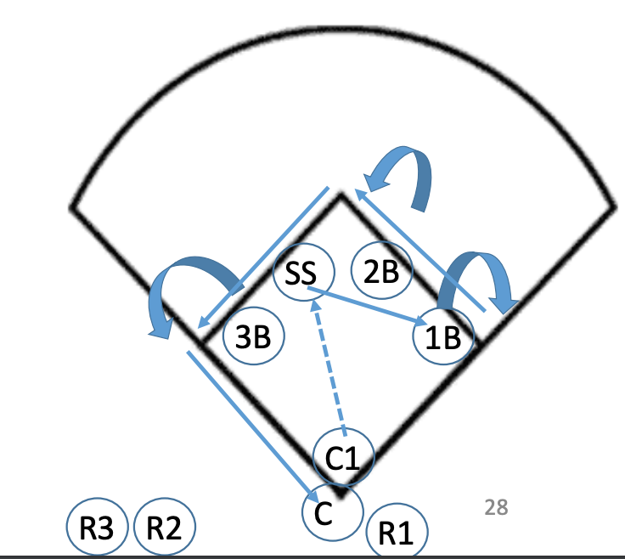

Final Practice
The entire final practice is run with water balloons rather than softballs. The kids love it! Get them to come back next year.
Time | Content
*Equipment: milk jugs with coaches’ faces on them, buckets, 200 water balloons
*Setup: Hide water balloons
5:00 - 5:05 | Warmups  - 2x around the bases  - 10 second forward arm circles  - 10 second backward arm circles  - 10 x jumping jacks  - 10 x cherry pickers
5:05  -  5:15 | Throw At The Coach’s Face  Start with softballs and keep the water balloons hidden  Bring 3 milk jugs with an inch of water in them. On the outside, paste a picture of the coach’s face. Ham it up about how much it hurts when they hit the milk jug.  Set up three stations with a milk jug on a bucket. About 15 feet away from the milk jug place a cone for the kids to throw from.
5:15  -  5:25 | Throw At The Coaches With Water Balloons  Surprise the kids with the water balloons  - Girls circle around coaches  - Toss them a softball.  - If they catch the softball, they get two water balloons to throw at the coaches.  - If they miss the softball, they only get one water balloon to throw at the coaches.
5:25  -  5:35 | Balloon toss  - Players pair in two lines  - All water balloons on one side  - On the coaches command, the players throw to their partner  - If their balloon pops they are out.
5:35  -  5:45 | Pop Flies
5:45  -  6:00 | Queen Of The Hill

